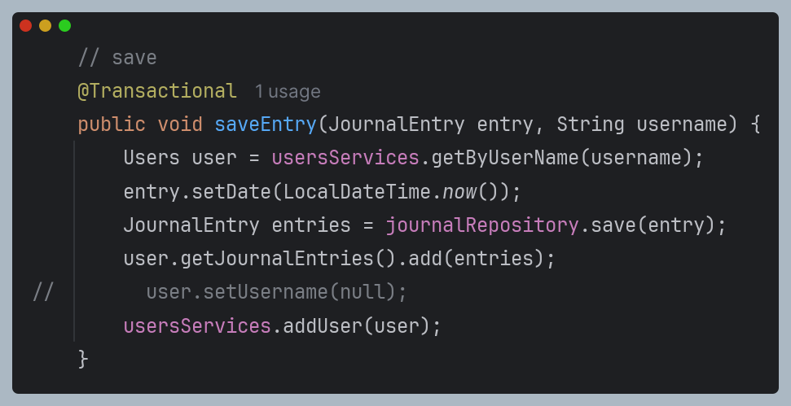@Transaction annotation

1)

2) Create a @Bean in a main application file

